JAVASCRIPT NOTES:

**DAY 7 🡪 31 - 05-2025**

**JAVASCRIPT:**

JavaScript was object based interpreter scripting language till ES5 version. From ES6 onward JavaScript also known as object oriented interpreter scripting language.

ECMA it is a concept. JavaScript is one of the implementation of ECMA.

Class keyword.

Using JavaScript we can do programming on web page without server.

If we want to display welcome message using JS. We need to use script tag inside html web page

Syntax

<script type=”text/JavaScript”> opening tag

We can do coding …….

</script> closing tag

**VARIABLE:**

variable is a name which hold the value.

In JS to declare the variable we need to use var keyword till ES5 from ES6 onward we can use let and const keyword.

Syntax

**var varibleName;**

var m; by default value of m is undefined.

var a=10; number type consider

var b=10.10; number type consider

var fname =”Ravi”; string type consider

var result = true; Boolean type consider

var obj =new Date(); object type consider

**OPERATORS:**

Operator is use to do some operation on variables.

Arithmetic operator: +, -, *, /

Conditional operator : >, >=, <, <=, ==, !=

Assignment operator: =

=== operator

Logical operator: && (if both condition true then result is true), || (any condition true then result is true), !

Increment and decrement operator: ++, --

**Conditional statement:**

1. **If statement**

If(condition) {

True block

}

1. **If else statement**

If(condition) {

True block

}else {

False block

}

1. **If else if statement**

If(condition1) {

}else if(condition2) {

}else if(condition3) {

}else {

}

1. **switch statement**

syntax

var n=10;

switch(variableName) {

case 1: block1;

break;

case 2: block2;

break;

case 3: block3;

break;

default : default block

break;

}

**LOOPING:**

Looping is use to execute the set of statement again and again till the condition become false.

**1) While loop:**

Syntax

Initialization : start position and end position var i=0,n=100;

while(condition i <=n) { entry look

do the task document.write(i)

increment or decrement. i++;

}

**2) Do while loop:**

Syntax

Initialization: start position and end position var i=0,n=100;

do {

do the task document.write(i)

increment or decrement

}while(condition) exit loop

**3) For loop:**

Syntax

1 2 4

for(initialization;condition;increment/decrement) {

body of the loop 3

}

for(var i=0,n=10; i <=n ; i++) {

document.write(i);

}

**TASK:**

1 to 10 tables

1*1=1 2*1=2 3*1=3

1*2=2 2*2=2 3*2=6

1*3=3 2*3=3 3*3=9

**FUNCTIONS**

Set of instruction to perform a specific task.

In JavaScript functions mainly divided into 2 types.

1. Pre defined or built in function
2. User defined functions

**1) Pre defined functions:**

1. alert() : it is use to do display pop message.
2. prompt() : this function is use to receive the value from keyboards.
3. parseInt() : it is use to convert string to integer without decimal number
4. parseFloat(): it is use to convert string to float with decimal number.
5. eval : it is use to convert string to number (it can be with or without decimal number).
6. Confirm : it display two button. If we click ok it return true if we click cancel it return false.

**2) User defined functions:**

In JS we can create user defined function with lot ways or different syntax.

1. Normal ways function creations

Syntax

function functionName(parameterlist) {

function body;

}

**DAY 8 🡪 01 - 06-2025**

**EVENTS**

Event helps us to provide the bridge between html and JS code. Whenever user interacts with any html tags it generates few events. As a developer, we need to handle the generated event and do some specific task based upon our requirements.

JavaScript provided lot of pre-defined events. All event starts with pre-fix ‘on’ followed by event name.

**-like:**

**onClick**

**onDblClick**

**onMouseOver**

**onMouseOut**

**onKeyUp**

**onKeyDown**

**onChange**

**onSubmit**

**onFocus**

**onBlur**

**onload**

**onUnLoad**  etc.,

html code

<input type=”button” value=”Click Here” onClick=”info()”/>

Js code

function info() {

}

**OOPS CONCEPT**

**Object:** any real-world entity.

Property or state --🡪 have 🡪

Person

Behaviour -🡪do/does

Bank, Customer, Employee, Car, Bike etc.,

Object is a concept

**Class:** class is a blue print of object or template of object etc.

User defined data types which help to describe the object.

In ES5 JavaScript to implements object concept we were/are using function but from ES6 onward we are using class keyword.

In JavaScript object are divided into 2 types.

1. Pre defined object or built in object
2. User defined object using function keyword or class keyword.

In JavaScript provided two pre defined object hierarchy

**BOM : Browser object model**

**DOM : document object model**

Object --🡪property (variables)

Behaviour (function)

Object --------🡪 property

Behaviour

Object ---🡪 property

Behaviour

Object

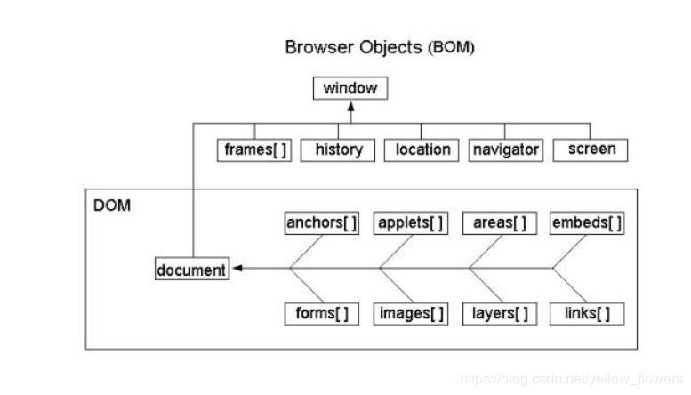

**document.write(“Welcome to JS”)**

document is pre defined object and write is function which help to display output on browser using JS.

window.document.write(“Welcome to JS”);

window.alert(“Welcome”);

**DOM hierarchy or DOM Parser**

JavaScript, Java, Python or other programming provided DOM parser which help to read, write and update html content dynamically.

External JS file

Create separate file with extension **.js**. inside this file you need to write JS code without script tags.

**ASSIGNMENT -1**

**🡪CREATE ONLINE CALCULATOR**

**1st Number Text Field**

**2nd Number Text Field**

**Result Text Field**

**Add Button Sub Button Mul Button Div Button**

**ASSIGNMENT -2**

**🡪Display product details like pid, pname and price in table format. Those data must be added dynamically (row must be dynamic)**

|  |  |  |
| --- | --- | --- |
| **Pid** | **PName** | **Price** |
| 100 | Laptop | 56000 |
| 101 | Computer | 34000 |

**ES6 NEW FEATURES :**

1. From ES6 onward we can declare the variable using var, let const keyword.

Using var we can re-declare same variable once again with same value or different values. But using let we can’t.

Using var we declare global or function scope variable. But using let we declare block scope.

Const keyword is use to declare the constant value. Means we can’t change the value.

1. Different types of function styles.
2. Normal function
3. Expression style function
4. Arrow function : in arrow function function keyword replace by => and curly braces not required if we are planning to write one line statement. Arrow function by default return the value without return keyword.
5. Callback function :

Passing the function name or function body or function itself to another function as a parameter is known as callback functions.

**DAY 9 🡪 07 - 06-2025**

**Array :** array is a user defined data type which is use to store more than one value of same or different types.

var a=10;

a=20;

var/let abc=[10,20,30,40,50,60]; literal style array declaration with initialization

var/let xyz=new Array(10,20,30,40,50,60); creating memory using new words in JS array is known as dynamic memory.

**JavaScript User defined objects**

**DAY 10 🡪 08 - 06-2025**

**SYNCHRONOUS AND ASYNCHRONOUS COMMUNICATION :**

* **Synchronous communication :**

It will execute the set of statement sequentially or one by one

console.log(“1st statement”);

console.log(“2nd statement”);

console.log(“3rd statement”);

synchronous function call

fun1();

fun2()

fun3();

* **Asynchronous communication**:

It will execute set of statement independently.

console.log(“1st statement”);

console.log(“2nd statement”); asynchronous

console.log(“3rd statement”);

asynchronous function call

fun1();

fun2()

fun3();

If we want to make asynchronous statement execution on client machine. JavaScript provided 3 functions

setTimeout()

setInterval()

clearInterval()

1st req to search some information from database

2nd req get some dynamic code or random code

3rd req simple static message

1 🡪passing emailid and password if correct open dashboard and display the message.

2🡪 open the dashboard once we get confirmation

Client Server

AJAX :

Asynchronous JavaScript and XML (eXtensible markup of language)

XMLHttpRequest() :

ActiveXObject() : these pre defined object allow to achieve core Ajax features.

**PROMISE** :

Promise is a pre defined object which help to handle asynchronous event of data of any type.

Promise can be resolved or rejected.

To handle the promise we need to use then() and catch(). If promise resolve then will call to load the promise data if promise rejected catch() call to handle the error.

**WEB SERVICE :**

Giving the service for web application when both the application running using different technologies or languages.

Amazon ----🡪 React or Angular or Python or Java

Payment ----🡪 Paypal

Paytm Java

Gpay Python

Phone pay .net

Credit card php

Debit card

Net banking

**XML / JSON :**

XML and JSON is common format we use in industry to share the data.

JavaScript provided pre defined function is **fetch().** This function is use to consume rest api or web service develop using any language.

**fetch(“url”).** Return type of fetch is promise object.

ES5 style handling asynchronous evet of data

fetch(“url”).then(result=>console.log(result)).catch(error=>console.log(error));

**ES6**

Then replace by await and async keyword.